Radial Invariance of R2Br

# Abstract

Data on the Interplanetary magnetic field from the Juno and ACE spacecraft was analysed to collect observations of the product of the square of heliocentric distance with the radial component of the magnetic field, R2Br which was determined to be a function of time. The range of data was collected from 2012, 2015 and 2016. This gave the conclusion that within error, R2Br was longitudinally invariant, when averaged over 2 solar cycles. Br was taken for both the negative and positive sectors to allow for a better comparison.

# Introduction and Theory

## Introduction/Motivation **[more specific numbers, dates, people, colder]**

NASA is expected to launch a spacecraft in July 2018, the first named after a living scientist [reference, NASA]. The Parker space probe is expected to reach Sun’s atmosphere where it will gather new data, to fuel more theories and deepen our understanding of the surface of our local star. Eugene Parker’s work does however have implications far beyond this, even to the edge of our solar system, where a colossal magnetic shield, the heliosphere, deflects interstellar radiation, known as cosmic rays.

In 1958, Eugene Parker wrote a paper titled ‘*Dynamics of the interplanetary gas and magnetic fields’ [reference, EP paper]*, proposing many of the current Ideas about the shape of the suns magnetic field. This was the first suggestion that the magnetic field was somehow distorted by the solar wind, which in itself had only recently been conceptualised [reference, Biermann].

Much work has been done since, with several space physics departments in the UK and worldwide tirelessly processing, researching and analysing data gathered from spacecraft sent to furthest planets and the fastest asteroids [reference]. Almost all of these spacecraft have continuously collected data on their long journey, providing crucial measurements of the Interplanetary Magnetic Field and the nature of the solar wind.

The magnetic field data used within this investigation came from the Juno and ACE spacecraft. The time range considered was the years 2012, 2015 and 2016, where Juno was separated by a significant distance from ACE. This enable comparison of the magnetic field at difference in radial distance from from 0.6 AU to 4.2 AU.

### Aims

The previous investigation into the time variation of an individual sector of R2Br was in 1996 [reference Smith and Balogh]. Over two solar cycle later, with a reduced solar maximum, new spacecraft, and a different latitude conditions, this investigations seeks to determine if the result of the radial invariance of R2Br can be replicated. This investigation will test the approach used, such as averaging over multiple solar cycles.

This investigation also sought to compare the data separated by 2 solar cycles. This meant a comparison of the same magnetic solar cycle, due to the switching of the direction of the magnetic dipole of the sun every solar cycle.

## Theory (subsections)

### Dynamo Theorem/ Magnetic Dipole

Electric current in the sun produce a magnetic field within the sun as shown by Dynamo theorem \Heliophysics. The sun therefore can be modelled as a magnetic dipole. The expectation would then be that the magnetic field should follow a 1/r3 relationship following a standard dipole field however, this is not the case. The solar wind drags out the magnetic field lines resulting in a signifcantly altered structure. This report seeks to determine the validity of using inverse square law to model the decrease in the magnetic field. Br is use here due predictions [reference Parker] the magnetic field is radially outward at the solar surface. The reasoning being the solar wind drags out the magnetic field lines to be approximately normal to the surface of the sun. Any change to the direction of the magnetic field will therefore be due to solar rotation, the radial component will continue to represent the field at the solar surface with a reduction in line with inverse square law.

[Diagram to clarify explanation]

### Frozen in Theorem and the Parker Spiral

The plasma of the solar wind is able to drag out the magnetic field lines due to the excellent electrical conductivity of the plasma resulting in it freezing in the magnetic field to follow the path of the solar wind.

The solar wind flows radially outward from the surface of the sun [reference], however as the sun rotates the stream of ions forms a spiral around the sun. This, along with the Frozen-In theorem leads to magnetic field lines with a direction that points at an angle to \hat{r}. Measurements of the field were taken in three spatial directions using the Radial-Transverse-Normal (RTN) system. The outward magnetic field had to be determined from the angle of the magnetic field and its magnitude from the Br component.

### Sunspot relation to magnetic field

Sunspots are where the magnetic field is said to poke through the solar surface so corresponds directly to the strength of the field lines originating from that section of the sun. Sunspots are often taken to be the measure of solar activity as they follow the 11 year cycle in solar activity.

There has been a significant decrease I the magnetic field over the previous half century. This has been matched by a reduction in the average number of sunspots counted.

### Fluctuations due to slow slower wind with more turbulence

The measurements made by Ulysses and IMP-8 in 1992 to 1995 were of high latitudes where the fast solar wind, approximately 700km s-1,is dominant [reference, Smith and Balogh]. Comparatively Juno and ACE made measurements of the ecliptic plane where the slow solar wind with an average velocity of 400km s-1,is dominant. This could lead to a much more tangled set of field lines with the negative and positive sectors not as well defined for Juno and ACE. The difference in reliability will be discussed.

Extra fluctuations between outward and inward field directions could be introduced due to differential rotation, where the rotation velocity of the sun is varies with latitude, and meridional circulation, where the ion move in polar directions [reference, Heliophysics book]. This presents extra fluctuations in the data as the field lines originate from different areas of the sun. This leads to the new areas of the sun producing a magnetic field lines, causing a change in the direction observed much further out from the sun.

# Method

The provided data was minute averaged for the times when Juno and ACE measured the magnetic field. It included information on the 3 vector components of the magnetic field according the RTN system. Data was also provided on the location of the spacecraft relative to the sun for Juno and relative to Earth for ACE.

*Python* was used to analyse the data, where it was converted into *Pandas* data frames to enable data handling.

[diagram RTN]

### Daily and Hourly averages

The data was first averaged into hourly set and any missing hours within the data was included was as ‘NaN’ values to make sure the data was not averaged over the time. This also allowed discontinuities in any graphs for where not data was available.

Daily averages were calculated to allow for a comparison to sunspot number were provided daily.

### Separation of negative and positive sectors

The angle of the outward and inward magnetic field was determined from \eqref{fig:1} so the inward and outward field could be determined. The angle provided was the angle to the \hat{r} vector. By rotating the angles so that any that were great than $90 ^{\circ}$, the new positive and negative angles determined the negative and positive sectors.

The negative and positive hours were then separated based on the sign of the angle. This allowed the negative and positive sector to be treated individually.

### Dipole switching of inward and outward field

Some fluctuations between negative and positive angles were at very low angles so could have been negative or positive within error. These were often on scale of less than 6 hours. To prevent this from invalidating the data, short fluctuations of less than 2 hours were removed from averaging if they were within error of the boundary between positive and negative.

### Averaging over solar cycles

It was decided to average over 2 solar periods as it was expected [reference] that shorter fluctuations would average to 0. This mould remove the effect of shorter-term contributions to the magnetic field from CME’s.

### Sunspot data obtained and overlaid\c

Sunspot data was provided by Royal Observatory of Belgium. This was plotted as a bar chart on the same axes as the magnetic field data.

# Errors

Error in the angle was calculated using the propagation of errors formula. This assumed an error in the speed of the solar wind of 50km s-1 and used the error in the solar rotation of 0.25 days [reference error in rotation period].

As can be seen from the figure, the peak was at -70 degrees when the angle between r and was taken into account.

# Results and Discussion

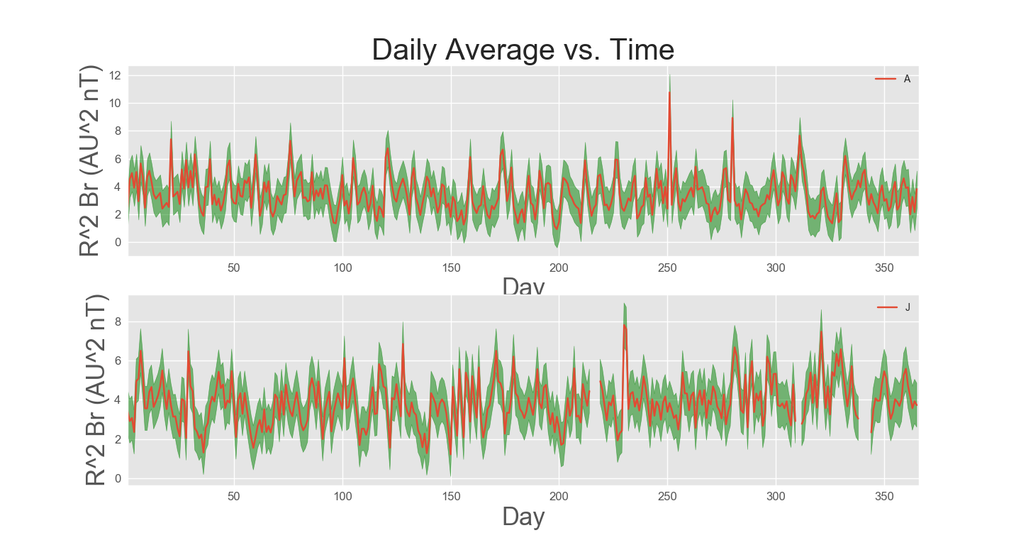

Averaging R2Br over period of 1 day showed the need for a longer period. The fluctuations are the result of CME’s. CME’s occur almost daily, releasing material [reference]. This causes the magnetic field to increase for a period averaged at roughly a day.

## Plot angle with distance and error

The error in the angle of 5 degrees meant that the positive and negative sector could not be identified for angles near boundary between the positive and negative sectors.

## Final Result

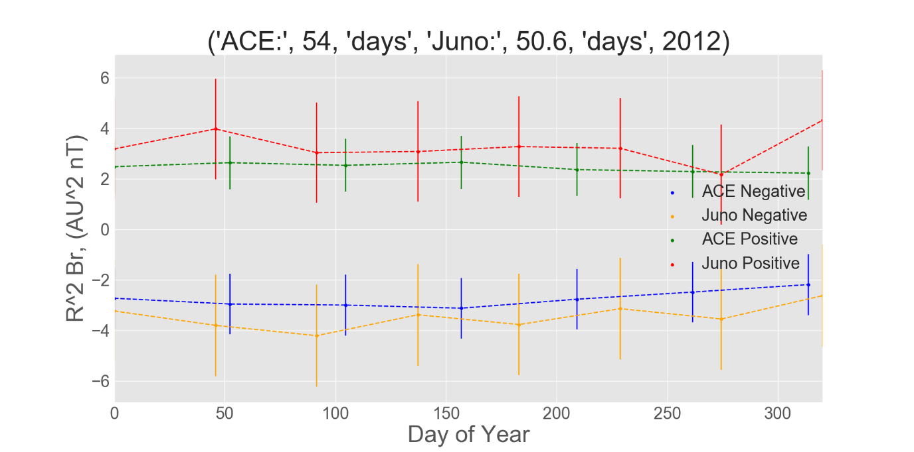

There were places where the data did not exactly follow a similar pattern for each sector.

### Heliosheath and termination shock

The relation between

The decrease in the magnitude of Br has implications for the reach of interstellar media. The sola magnetic field is responsible for the Helios heath so without it the interstellar media would just be able to enter the solar system and contribute significantly to solar weather.

[image of heliosheath]

# Conclusion

Within error, R2Br was radially invariant in the ecliptic plane for 2012, 2015 and 2016. This verified the use of inverse square law to model the magnetic field strength of the negative and positive sectors.

# References

Sunspots - <http://www.sidc.be/silso/infosndtot>